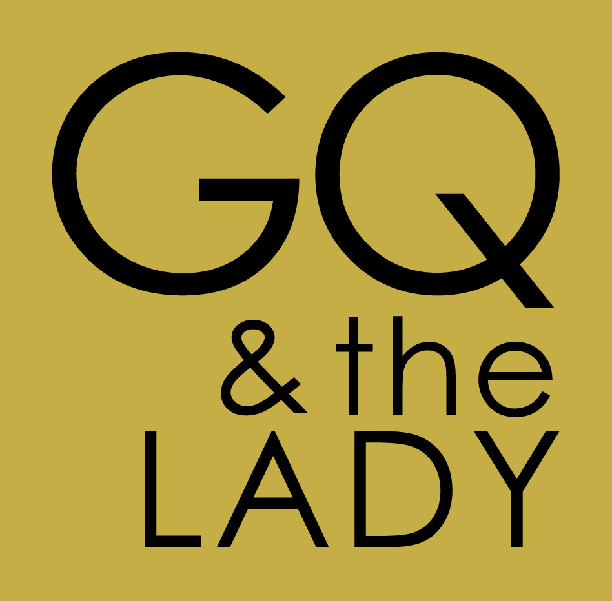 Songlist
Contemporary Hits

24 Karat Magic Bruno Mars
All About That Bass Meghan Trainor
All of Me John Legend
Amazing (Just the Way You Are) Bruno Mars
Bad Romance Lady GaGa
Blurred Lines Robin Thicke
Can’t Stop the Feeling Justin Timberlake
Closer Chainsmokers
Crazy in Love Beyonce’
DJ Got Me Falling In Love Usher
Dynamite Taio Cruz
Edge of Glory Lady Ga Ga
Feel It Coming Portugal the Man
Forget You Cee Lo Green
Get Lucky Daft Punk
Happy Pharrell
Hey Soul Sister Train
Hold On We’re Going Home Drake
Home Phil Phillips
Hotline Bling Drake
I Love It Icona Pop
I Think I Wanna Marry You Bruno Mars
I’m Yours Jason Miraz
It’s Gettin Hot In Here Nelly
Just Dance Lady GaGa
Just The Way You Are Bruno Mar
Locked out of Heaven Bruno Mars
Love On the Brain Rihanna
Low Flo Rida
Me Too Meghan Trainor
Million Reasons Lady GaGa
Only Gurl in the World Rihanna
Party Rock Anthem LMFAO
Say You Won’t Let Go James Arthur
Shake It Off Taylor Swift
Shallow Lady GaGa
Shut Up and Dance Walk the Moon
Sugar Maroon 5
Suite and Tie Justin Timberlake
Teenage Dream Kati Perry
That’s What I Like Bruno Mars
Thinking Out Loud Ed Sheeran
Time of My Life Flo Rida
Tonights Gonna Be a Good Night Black Eyed Peas
Uptown Funk Bruno Mars
Why Don’t We Just Dance Josh Turner

70’s, 80’s, 90’s Hits
Ain’t Nobody Chaka Kahn
American Girl Tom Petty
Been a Long Time Led Zepplin
Billie Jean Michael Jackson
Black Magic Woman Santana
Boogie Oogie A Taste of Honey
Brick House The Commodores
Bust a Move Young MC
Bye Bye Bye NSync
Can’t Get Enough Barry White
Can’t Take My Eyes Off You Lauryn Hill
Carwash Rose Royce
Clocks Coldplay
Crash Into Me Dave Matthews Band
Dancing Queen Abba
December 1963 The Four Seasons
Dirty Water The Standells
Do You Remember the Time Michael Jackson
Don’t Stop Believing Journey
Don’t Want no Scrub/Waterfalls TLC
Everybody Backstreet Boys
Everybody Dance Now CC Music Factory
Faith George Michael
Footloose Kenny Loggins
For Once In My Life Stevie Wonder
Forget Me Nots Patrice Russian
Gettin Jiggy With It Will Smith
Glory Days Bruce Springsteen Cyndi Lauper
Good Vibration Markie Mark & The Funky Bunch
Have a Heart Bonnie Raitt
Hey Ya Outkast
Hit Me Baby One More Time Brittany Spears
Honky Tonk Woman The Rolling Stones
Holiday Madonna
Hollywood Swingin Kool and the Gang
Hot, Hot, Hot Buster Poindexter
How Sweet It Is James Taylor
I Feel For You Chaka Kahn
I Wanna Dance With Somebody Whitney Houston
I Will Survive Gloria Gaynor
I’m Comin Out Diana Ross
It Takes Two Rob Base
Jungle Love Morris Day and the Time
Just Got Paid Johnny Kemp
Kiss Prince
Ladies Night Kool and the Gang
Lady Marmalade Pink, Christina Aguiliara
Last Dance Donna Summer
Let’s Stay Together Tina Turner
Livin on a Prayer Bon Jovi
Love Come Down Evelyn Champagne King
Margaritaville Jimmy Buffet
More Money More Problems Biggie Smalls/Puff Daddy
My Perogative Bobby Brown
No Diggity Backstreet
Old Time Rock and Roll Bob Segar
On The Radio Donna Summer
Piano Man Billy Joel
Play That Funky Music Wild Cherry
Poison Bel Biv Devoe
Pony Ginuine
Pour Some Sugar on Me Def Leperd
Push It Salt n Peppa
Ramblin Man The Allman Brothers
Real Love Mary J. Blige
Rock Your Body Justin Timberlake
Say My Name Destiny’s Child
September Earth Wind And Fire
Shook Me All Night Long AC/DC
Simply the Best Tina Turner
Signed Sealed Delivered Stevie Wonder
Smooth Santana
Start Me Up The Rolling Stones
Stir It Up/Three Little Birds Bob Marley
Sunday Morning Maroon 5
Sweet Home Alabama Lynyrd skynyrd
Sweetest Taboo Sade’
That Thing Lauryn Hill
The Way You Make Me Feel Michael Jackson
This is How We Do It Montell Williams
Thriller Michael Jackson
Toxic Britney Spears
Use Me Up Bill Withers
Walk This Way Aerosmith/Run DMC
Wanabe Spice Girls
We are Family Sister Sledge
What a Man Salt n Peppa
What’s Goin On Marvin Gaye
What’s Up Four Non Blonds
Vogue Madonna
You Oughta Know Alannis Morrisette
Your Love Outfield
You’re the First, Last, My Everything Barry White
Yeah Usher

Motown and 60’s
Ain’t No Mountain High Enough The Supremes
Dancing in the Streets Martha & the Vandella’s
For Once In My Life Stevie Wonder
Give Me Shelter Rolling Stones
I Feel Good James Brown
Isn’t She Lovely Stevie Wonder
I Want You Back The Jackson 5
I Wish Stevie Wonder
PaPa’s Got a Brand New Bag James Brown
Proud Mary Tina Turner
Rescue Me Fontella Bass
Respect Aretha Franklin
Ring of Fire Johnny Cash
Shout Otis Day & the Knights
Signed Sealed Delivered Stevie Wonder
Something The Beatles
Superstition Stevie Wonder
Twist Chubbie Checker
Twist and Shout The Beatles
Standards and Swing
Ain’t That a Kick in the Head Dean Martin
Fly Me to the Moon Frank Sinatra
Georgia Ray Charles
Good Morning Heartache Billie Holiday
Everything Michael Buble
I Got You Under My Skin Diana Krall
In the Mood Standard Swing
I Wish You Love Standard
La Vie En Rose Edith Piaf
LOVE Natalie Cole
Mack The Knife Bobby Darin
New York New York Frank Sinatra
Old Cape Cod Patty Page
Our Love is Here to Stay Natalie Cole
Route 66 Natalie Cole
Save the Last Dance Michael Buble’
Smooth Operator Sade’
Summerwind Frank Sinatra
Sway Michael Buble’
That’s All Standard
The Very Thought of You Natalie Cole
The Way You Look Tonight Frank Sinatra
They Can’t Take That Away Natalie Cole
What a Wonderful World Louis Armstrong

Ballads
At Last Etta James
Because You Loved Me Celine Dion
Bubbly Colby Caillat
Come Away With Me Nora Jones
Could I Have This Dance Ann Murray
Crazy Patsy Cline
Don’t Know Why Nora Jones
Easy The Commodores
Fields of Gold Eva Cassidy
God Bless the Broken Road Rascal Flatts
Have I Told You Lately Van Morrison
I Can’t Help Falling in Love Elvis Presley
If I Ain’t Got You Alicia Keys
I Loved Her First Father/Daughter Dance
I Need You Now Lady Antebellum
Just the Way You Are Billy Joel
Killing Me Softly Lauren Hill
Landslide Stevie Nicks
Love Song Adele
Lucky Jason Miraz/Colby Caillat
Make You Feel My Love Addele
My Wish Rascal Flatts
Sea Of Love Cat Power
Say You Won’t Let Go James Arthur
She Will Be Loved Maroon 5
She’s Got a Way Billy Joel
Song For My Son Son/Mother Song
Songbird Eva Cassidy
Sunday Kind of Love Etta James
Sweet Thing Chaka Kahn
Tennessee Whiskey Chris Stapleton
Then Brad Paisley
The First Time Ever I Saw Your Face Roberta Flack
Through the Fire Chaka Kahn
Time After Time Cyndi Lauper
The Closer I Get to You Roberta Flack
Valentine Martina McBride
Wicked Game Chris Isaacs
When You Say Nothing At All Allison Kraus
Wonderful Tonight Eric Clapton
You’re the Best Thing Gladys Knight
Your Song Elton John

